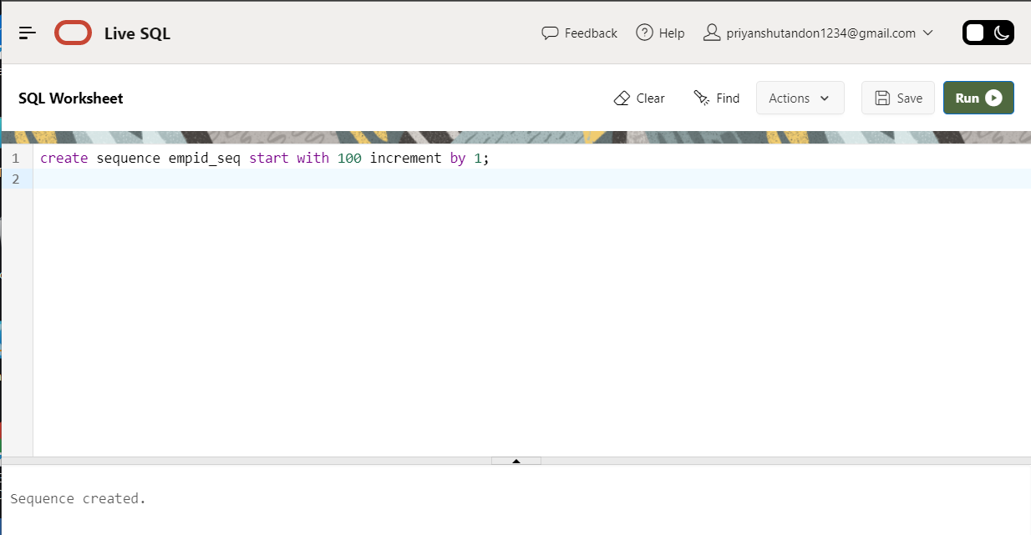Q1- Create a sequence by name EMPID_SEQ starting with value 100 with an interval of 1

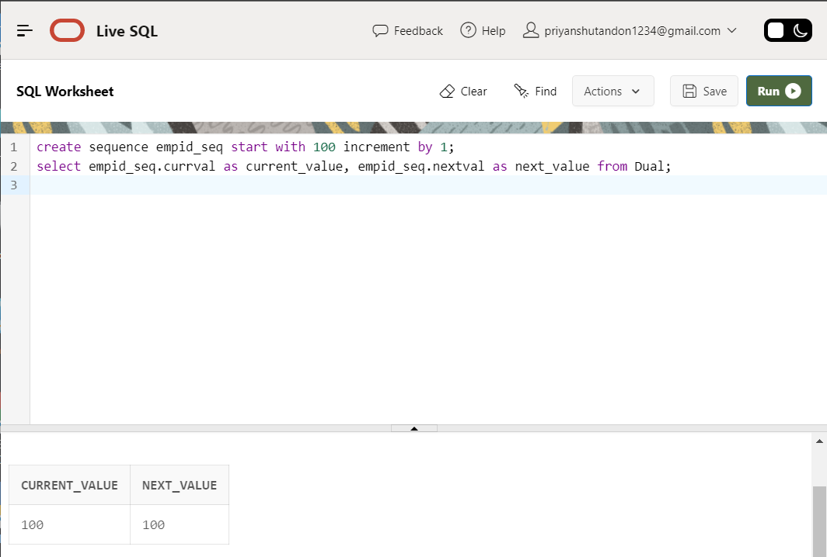Q2- Write a SQL command for finding the current and the next status of EMPID_SEQ.

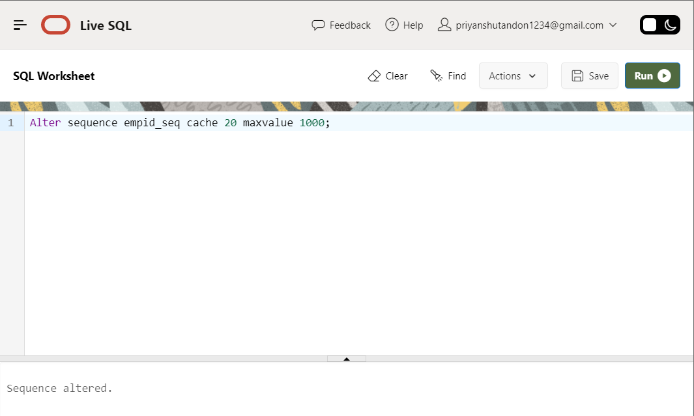Q3- Change the Cache value of the sequence EMPID_SEQ to 20 and maxvalue to 1000

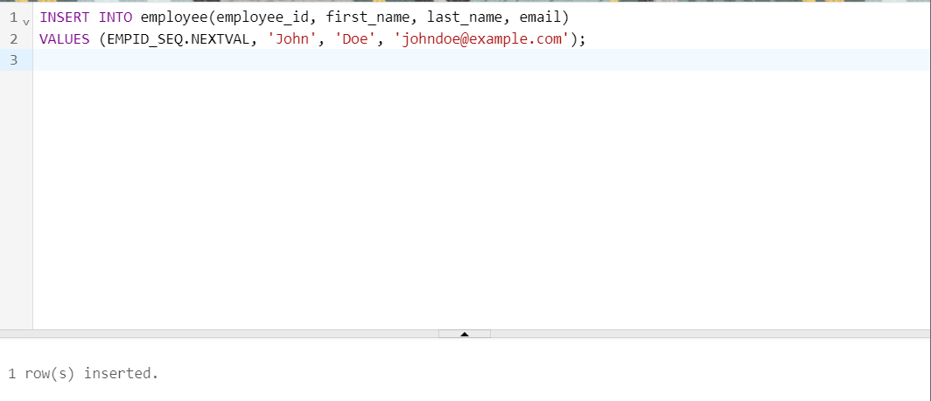Q4- Insert values in employees table using sequences for employee_id column

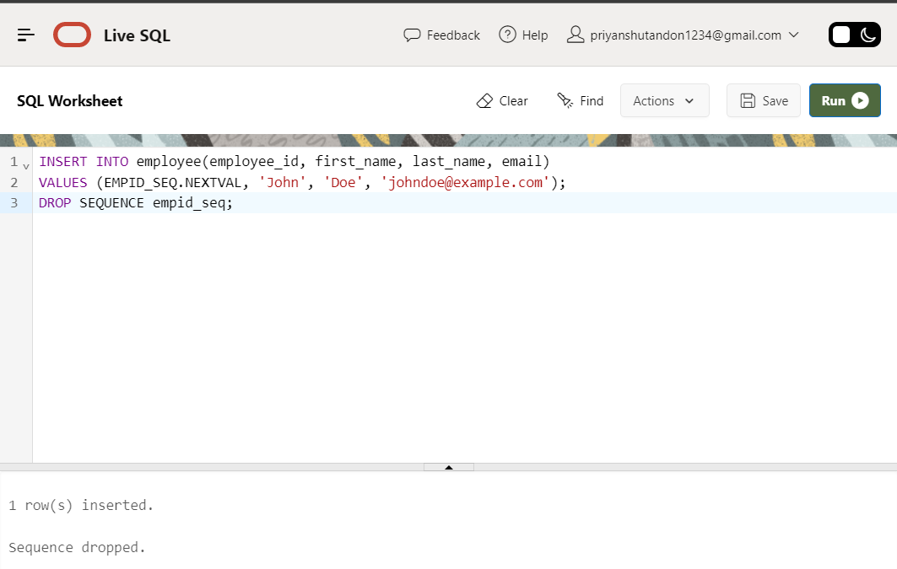Q5- Drop sequence EMPID_SEQ.

Q6- Create a sequence called REVERSE to generate numbers in the descending order from10000 to 1000 with a decrement of 5

